土木工程系0306岗位专业测试方案

一、专业测试
专业测试满分100分。本方案测评0306岗位应聘者适应岗位所要求的专业技能。专业测试时间为120分钟，简答题及计算机内业绘图80分钟（室内考核场地），无人机操作20分钟（室外考核场地）。全站仪操作20分钟。
二、专业测试时间、地点
- 测试时间为2021年3月 13 日9：30开始。
2.地点：
考场：尚技楼三楼数字化测图实训室，候考室：尚技楼一楼楼空间数据实训室。
三、专业测试流程及注意事项
专业测试人员携带身份证，提前20分钟到达候考室。
- 在测试开始前10分钟集中抽签决定考位。
- 测试开始前5分钟，由工作人员带领测试人员进入考场，对号入坐。
- 请带黑色签字笔，铅笔备用。
- 咨询电话：陈老师 15338511244
四、专业测试内容
专业测试满分100分，内容根据考生报名时填写的专业特长进行制定。
1. 计算机内业绘图。（50分）
要求：按照提供的测量坐标数据文件“test.DAT”和“外业记录的点性及草图（见附件2）”用cass软件完成地形图绘制。文件保存路径：D：/专业考核/考号（根据本人考号新建）/第二题
考前将测量坐标数据文件“test.DAT”复制到考生计算机中，“外业记录的点性及草图（见附件2）”打印后发给考生。
绘图要求：
（1）绘图比例尺1：500
（2）按照“外业记录的点性及草图（见附件1）”绘制地物和地貌符号
（3）要求绘制等高线，等高距1米
（4）采用矩形分幅，不标注测绘单位及绘图员
（5）图幅左下角信息如下：
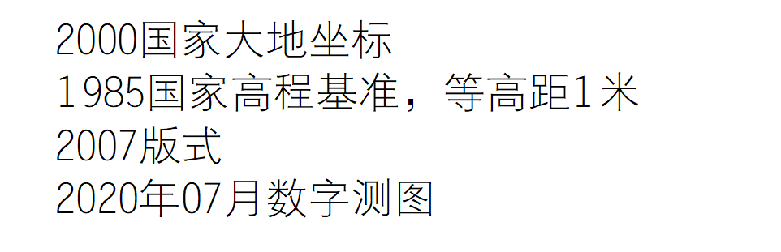
（6）外业数据如下：

1,,53167.880,31194.120,495.800
2,,53151.080,31152.080,495.400
4,,53174.690,31109.490,499.300
5,,53161.730,31117.070,497.400
6,,53154.150,31129.070,495.800
7,,53142.780,31122.750,494.500
8,,53129.510,31124.970,492.300
9,,53102.970,31185.590,493.700
10,,53106.130,31206.430,494.700
11,,53110.860,31171.060,492.500
12,,53120.980,31184.010,493.300
13,,53124.450,31200.740,494.200
14,,53124.770,31216.210,495.100
15,,53116.550,31156.220,491.200
16,,53132.030,31169.170,492.200
17,,53130.770,31156.850,491.900
18,,53138.040,31187.480,493.200
19,,53143.720,31203.900,494.100
20,,53148.150,31221.270,494.500
21,,53116.754,31141.585,490.400
22,,53106.161,31137.542,490.441
23,,53133.631,31135.089,491.781
24,,53150.419,31141.778,494.210
25,,53168.235,31179.229,495.446
26,,53183.471,31151.399,499.709
27,,53181.314,31137.209,500.135
28,,53182.274,31122.512,500.228
29,,53167.215,31128.245,498.172
30,,53165.505,31145.993,497.859
31,,53180.278,31168.288,498.296
32,,53190.368,31174.877,498.980
33,,53185.628,31179.702,498.535
34,,53188.893,31187.954,498.972
35,,53187.747,31196.076,498.599
36,,53176.685,31209.078,497.000
37,,53161.315,31214.692,494.897
38,,53151.904,31195.396,494.247
39,,53143.528,31175.002,492.553
40,,53136.817,31153.427,493.798
41,,53128.031,31140.155,492.225
42,,53116.101,31129.079,491.766
43,,53100.000,31200.000,494.600
44,,53100.000,31100.000,500.000
45,,53136.693,31223.800,0.000
46,,53134.228,31214.675,0.000
47,,53112.625,31190.051,0.000
48,,53097.691,31180.636,0.000
49,,53161.472,31173.024,0.000
50,,53162.272,31155.439,0.000
51,,53168.673,31155.759,0.000
52,,53176.033,31161.833,0.000
53,,53175.444,31173.642,0.000
54,,53203.302,31152.456,0.000
55,,53196.508,31142.986,0.000
56,,53191.452,31118.835,0.000
57,,53190.662,31106.050,0.000
58,,53196.280,31163.753,0.000
59,,53201.413,31215.435,0.000
60,,53110.272,31091.172,0.000
61,,53110.472,31075.747,0.000
62,,53117.667,31075.747,0.000
63,,53131.758,31080.247,0.000
64,,53117.967,31086.230,0.000
65,,53117.967,31091.172,0.000
66,,53105.808,31068.073,0.000
67,,53142.472,31068.483,0.000
68,,53141.651,31098.687,0.000
69,,53135.641,31226.915,0.000
70,,53125.468,31203.823,0.000
71,,53108.300,31188.158,0.000
72,,53116.538,31174.636,0.000
73,,53235.368,31160.728,0.000
74,,53249.468,31160.728,0.000
75,,53134.453,31056.221,0.000
76,,53225.182,31099.395,0.000
77,,53234.231,31099.454,0.000
78,,53234.054,31094.992,0.000
79,,53211.685,31150.213,0.000
80,,53280.718,31167.788,0.000
81,,53286.090,31215.608,0.000
82,,53211.605,31234.638,0.000
83,,53199.007,31078.540,0.000
84,,53265.749,31094.341,0.000
85,,53284.346,31113.094,0.000
86,,53230.181,31099.427,0.000
87,,53231.758,31110.380,0.000
88,,53249.298,31123.178,0.000
89,,53263.684,31142.670,0.000
90,,53269.793,31157.042,0.000
91,,53264.317,31165.234,0.000
92,,53137.455,31237.455,0.000
93,,53164.994,31234.518,0.000
94,,53165.767,31221.535,0.000
95,,53192.223,31207.470,0.000
96,,53196.400,31195.105,0.000
97,,53139.085,31195.446,0.000
98,,53151.415,31224.504,0.000
99,,53221.179,31148.025,0.000
100,,53218.604,31126.680,0.000
101,,53201.872,31099.678,0.000
102,,53266.484,31074.218,0.000
103,,53149.238,31099.646,0.000
104,,53164.158,31092.057,0.000
105,,53191.558,31089.889,0.000
106,,53218.278,31095.039,0.000
121,,53148.079,31166.628,494.090
122,,53153.096,31163.619,494.100
123,,53160.208,31164.186,495.810
124,,53160.293,31159.014,495.860
125,,53151.828,31158.447,494.120
126,,53142.376,31163.091,494.100
127,,53136.972,31171.640,492.560

2. 按照《工程测量规范》（GB50026－2007）的要求，使用全站仪（测角精度2″，测距精度2mm+2mm/km*D）完成竖直角一测站上的测量任务，（40分）（室外考核场地，时间20分钟）
（1）开考前考生熟悉仪器（时间不超过10分钟）
（2）开考前向考生通报温度和气压
（3）在测站点上标注点名，在照准点上事先安置好觇标，并向考生通报照准点的点名。
（4）要求竖直角采用测回法观测法测量，观测2个方向，限差符合规范要求。
观测数据记录在表格内（见附件2），观测者写考号。

3、无人机实操考核 ： 操作大疆P4R+PPK套装带回传无人机升空飞行（10分）
（1）开考前考生熟悉无人机（时间不超过10分钟）
（2）控制无人机升空50M后飞行3分钟即可降落。
（3）此项考核不用提供数据。
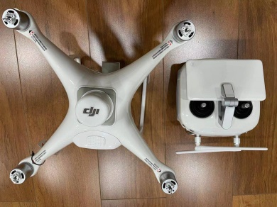

附件1

外业记录的点性及草图如下：

围墙外侧点：68、67、66，墙宽0.5m
拟合的小路：86、87、88、89、90、91
拟合的不依比例乡村路：103、104、105、106
路灯：69、70、71、72、97、98
宣传橱窗：73、74
不依比例肥气池：59
水井：79
电杆：75、83、84、85
果树独立树：99、100、101、102
菜地：58、80、81、82
埋石图根点：1（D121）、2（D123）、4（D135）
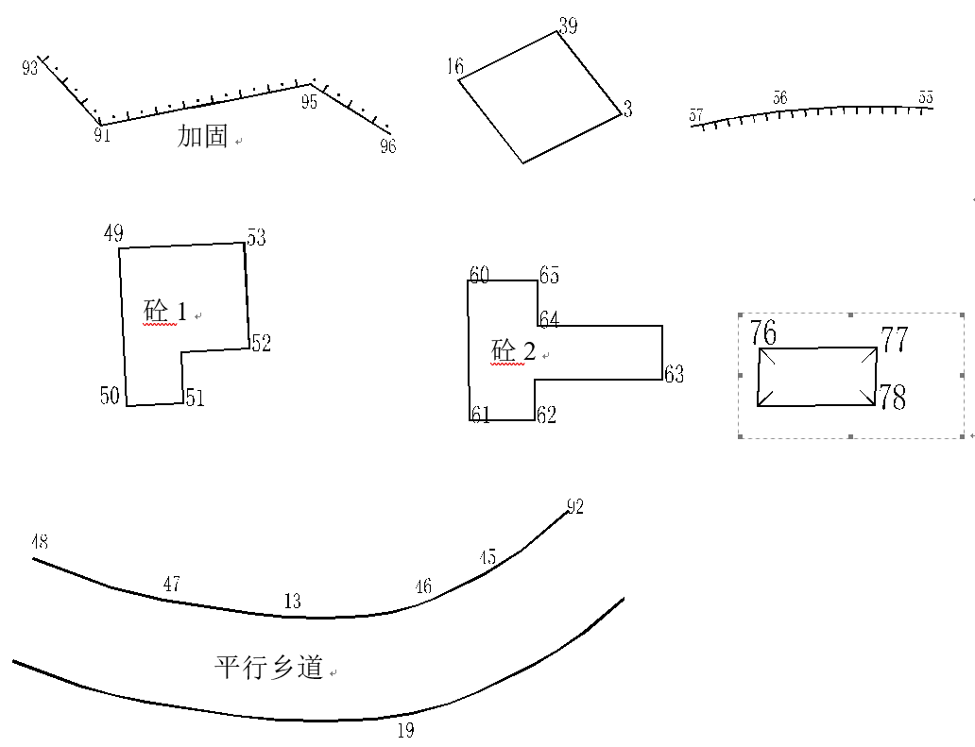
5
3
台阶
棚房
草图

附件2 实操题
用全站仪（苏一光）和已架设好的目标，完成2个方向竖直角观测记录与计算。
竖直角观测记录表
测站 | 测点 | 竖盘位置 | 竖盘读数  （ ° ' ″ ） | 半测回角值  （ ° ' ″ ） | 指标差  （″） | 一测回角值  （ ° ' ″ ） | 备注
O | A | 左
O | A | 右
O | B | 左
O | B | 右
O | C | 左
O | C | 右
O | D | 左
O | D | 右
备注 | 上半测回角值：α左=90°-L 下半测回角值：α右=R- 270°  竖盘指标差：x=12（L+R-360°） 一测回角值：α=α左+α右2

